ASSESMENT TOOL 2
CO1 AT2 concept mapping
NAME: CHANDRA KALA TORAM
REG NO: 192372224
COURSE CODE: CSA5110
COURSE NAME: CRYPTOGRAPHY AND NETWORK SECURITY
1.
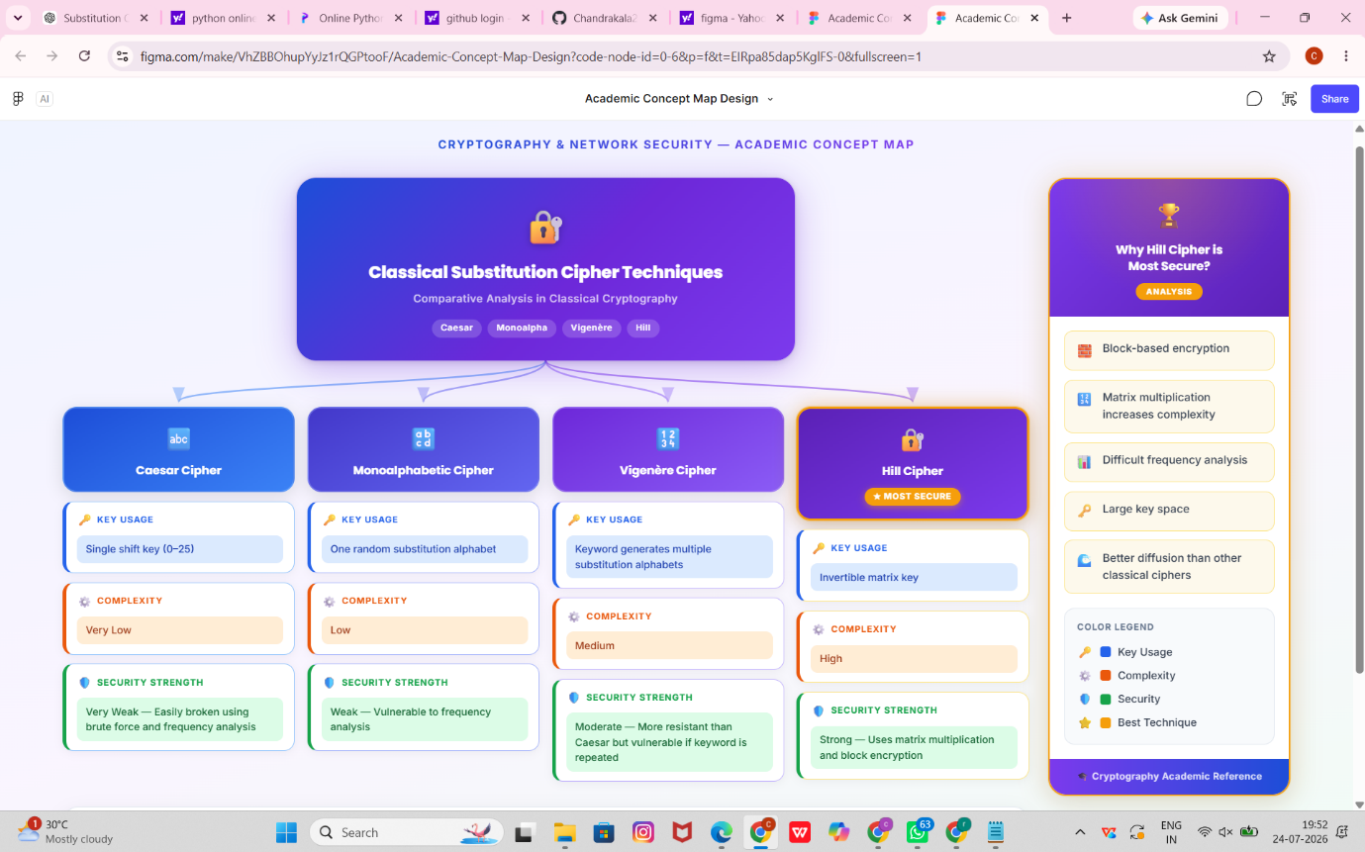
2. 